# **OPTIMISING TIME-LIMITED NON-PHARMACEUTICAL INTERVENTIONS FOR COVID-19 OUTBREAK CONTROL**

Alex L.K Morgan1, Mark E.J Woolhouse2, Graham F. Medley3 and Bram A.D van Bunnik2

1Centre for Immunity, Infection & Evolution and School of Biological Sciences, University of Edinburgh, Edinburgh, United Kingdom

2Usher Institute, University of Edinburgh, Edinburgh, United Kingdom

3Centre for Mathematical Modelling of Infectious Diseases and Department of Global Health & Development, London School of Hygiene and Tropical Medicine, London, United Kingdom

KEYWORDS: COVID-19/ Modelling/ Optimisation/ Epidemiology/ Non-pharmaceutical interventions

## **ABSTRACT**

Retrospective analyses into the non-pharmaceutic interventions (NPIs) used to combat the ongoing COVID-19 outbreak has highlighted the potential of optimising interventions. These optimal interventions allow for policy makers to manage NPIs in order to minimise the epidemiological and human health impacts of both COVID-19 and the intervention itself. Here, we use a susceptible-infectious-recovered (SIR) mathematical model to explore the feasibility of optimising the duration, magnitude and trigger point of five different NPI scenarios to minimise the peak prevalence and attack rate of a simulated UK COVID-19 outbreak.

An optimal parameter space to minimise the peak prevalence and the attack rate was identified for each intervention scenario, with each scenario differing with regards to how reductions to transmission were modelled. However, we show that these optimal interventions are fragile, sensitive to epidemiological uncertainty and prone to implementation error. We highlight the use of suboptimal interventions as a more robust alternative. While not as effective as optimal interventions, suboptimal interventions are still capable of reducing peak prevalence and attack rate over a wider, more achievable parameter space. This work provides an illustrative example of the concept of intervention optimisation across a wide range of different NPI strategies.

## **INTRODUCTION**

The ongoing COVID-19 pandemic has highlighted the vital role of non-pharmaceutical interventions (NPIs) in mitigating the spread of SARS-COV-2. These interventions aim to break chains in transmission through population and individual-level behavioural changes, which can consequently reduce opportunities for transmission (1). NPIs encompass a large range of potential outbreak control strategies, ranging from simple advice to encourage hand-washing to country-wide, severe “lockdown” measures such as stay-at-home orders, mobility restrictions and closure of non-essential businesses (2).

While an effective tool to drive down disease prevalence, severe NPIs are considered unsustainable and time-limited, with economical, physical and mental health repercussions during and following the cessation of these interventions (3-5). This has driven calls to retrospectively understand the epidemiological and human health impacts of introducing severe NPIs under a different set of circumstances (6-8). This includes insight into how differences in the timing, duration and strength of these interventions could have potentially altered COVID-19 associated mortality and morbidity compared to the actual course of action.

Exploratory mathematical modelling into optimising NPIs has arisen from these retrospective analyses (9-15). The concept of intervention optimisation is based on the potential for policy makers to fine-tune the characteristics of an intervention to minimise epidemiologically relevant outcome measures. This includes minimising the peak incidence, analogous to “flattening the curve” of an outbreak. The importance of this was illustrated during the early COVID-19 outbreaks in Lombardy, Veneto and Wuhan, with the overwhelming of health service capacity resulting in significant increases in patient mortality (16, 17).

Optimisation has been explored for a range of potential COVID-19 NPI strategies, including single time-limited reductions to transmission (9, 10), intermittent pulsing of NPIs (14) and gradual ramping-down of intervention measures following an initial reduction to transmission (11, 12). Despite an optimal parameter space being identified for each of these explored interventions, the ability for policy makers to achieve these results in practice has been questioned (9). This stems from the narrow windows for optimal timing and the severe adverse epidemiological outcomes borne out of intervention implementation error (9, 11). An alternative strategy is to use generalised intervention strategies, including longer-than-optimal or earlier-than-optimal interventions, with the aim to identify a broad and achievable parameter space that may be suboptimal, but still capable of mitigating the detrimental epidemiological impacts of COVID-19 (9). While not as obviously beneficial as an optimal intervention, these suboptimal interventions are more robust to implementation error and offer more practical and flexible guidance to policy makers than specific optimal intervention timings or durations.

This study aims to provide a mathematical modelling framework to explore the concept of optimal and suboptimal interventions across a range of different NPI scenarios. We explore and compare the existence, patterns and optimal parameter spaces for each intervention to minimise the peak prevalence or the attack rate of a simulated outbreak. This was explored for three main parameters: 1) intervention duration, 2) intervention strength and 3) the intervention trigger point. The results from this study are not intended to highlight an absolute best course of action. Rather this analysis provides an illustrative example to describe how optimal and suboptimal outbreak control can be achieved under different circumstances and intervention strategies.

## **METHODS**

* 1. **SIR Model Structure**

A deterministic SIR model (18) was used to explore the impact of time-limited non-pharmaceutical interventions (NPIs) on a simulated UK-based COVID-19 outbreak. *S*, *I* and *R* compartments were used to denote the fraction of susceptible, infected and recovered individuals respectively within the population(eqn 1.1).

$$\frac{dS}{dt}=-β(t)SI$$

$$\frac{dI}{dt}=β(t)SI-γI$$

$$\frac{dR}{dt}=γI$$

eqn 1.1

Susceptible individuals (*S*) are infected at the time-varying rate *β**(t)*, which represents the daily per-capita rate of transmission in a randomly-mixing population. Infected individuals (*I*) recover at rate *γ*, representing the daily per-capita rate of recovery. This rate was taken as the inverse of the average duration of infectiousness. A baseline pre-NPI basic reproduction number (*R0*) of 2.8 and doubling time (*Td*) of 3 days were assumed (19-23). The generation time was calculated as a function of these two quantities (24), with a baseline generation time of 7.79 days and a resulting *γ* of 0.128 day-1 (eqn 1.2).

eqn 1.2

* 1. **Defining the time-varying β(t)**

By setting *β = R0γ*, we define the baseline per-capita transmission rate in the absence of NPIs, *β =* 0.359 day-1. To capture the impact of smaller scale NPIs, *β* was multiplied by a scaling factor of 0.7, *βscale* = 0.252 day-1, with this 30% reduction being roughly in line with estimates of the impact of NPIs, such as school-closures, introduction of social distancing and isolation upon COVID-19 symptoms, and excluding severe NPIs, such as stay-at-home orders (23, 25, 26). We assume that these measures are in place at the initiation of the model simulation. Using the UK as a representative example, these measures were introduced between 12-21st March 2020 with severe “lockdown” measures initiated on the 25th March 2020 (26). However, it was not the intention of this study to model the exact timing of the UK outbreak response, rather use the epidemiological characteristics of the UK outbreak as motivation for this study.

*β(t)* is defined as the product of *βscale* and a time-varying scaling factor *c(t)*, which reduces *βscale* over the course of the simulation to model the impact of severe NPI measures, with 0 ≤ *c(t)* ≤ 1 (eqn 1.3). Reductions associated with this scaling factor are introduced on the trigger point, *tp* and with *dt* describing the duration of the intervention.

$$β(t)=\left\{\begin{aligned}β_{scale}, &t<t_{p} \\ {c(t)β}_{scale}, &t_{p}≤t≤t_{p}+d_{t} \\ β_{scale}, &t>t_{p}+d_{t}\end{aligned}\right.$$

eqn 1.3

The shape of the *c(t)* factor varies with the different intervention scenarios explored, with parameter *cmin* describing the minimum value of *c(t)* during the intervention. This can be considered a proxy measure of the magnitude of the intervention. For baseline reductions to *β(t)* we define *cmin* = 0.4, resulting in *β*(t)= 0.101when the NPI measures are at their greatest magnitude*.* Baseline *cmin* was chosen to roughly achieve an effective reproduction number (*Re*) of 0.7 ≤ *Re(t)* ≤ 1 during the intervention (23, 25, 26), with *Re(t)* defined as *R0S(t)*. All interventions were initiated at baseline *tp* = 52 days, equivalent to an attack rate at the initiation of the severe NPI measures of *Ic*(52)= 0.02, in line with model-based UK COVID-19 estimates (26). The model was seeded with an initial infectious fraction, *I*(0) = 0.00001.

* 1. **Single period of severe non-pharmaceutical interventions**

A time-limited period of severe NPI measures was the primary intervention explored in this model, with optimisation occurring in relation to this intervention. We explored five different intervention scenarios, with each scenario differing with regards to the shape of *c(t)* and the subsequent *β(t)* reductions over the duration of the intervention, (*dt*) (Table 1). The total duration of the simulation, *tmax*, was set at 400 days and 1000 days for all other sensitivity analyses. We provide the rationale and real-world parallels for each scenario in the supplementary material.

**Table 1.** Description of the five intervention scenarios.

|  |  |  |
| --- | --- | --- |
| Scenario | Description of *c(t)* | Definition of *c(t)* |
| 1 | Immediate and constant reduction to *cmin*. |  |
| 2 | Immediate reduction to *cmin* followed by a linear increase back to *c(t)* = 1. | $$c(t)=c_{min}+\frac{1-c_{min}}{d_{t}}(t-t_{p})$$ |
| 3 | Linear decrease to *cmin* followed by an immediate return to *c(t)* = 1. | $$c(t)=1-\frac{1-c_{min}}{d_{t}}(t-t_{p})$$ |
| 4 | Linear decrease to *cmin* at *dt*/2, followed by a linear increase back to *c(t)* = 1. | $$c(t)=\left\{\begin{aligned}1-\frac{1-c_{min}}{\frac{d_{t}}{2}}(t-t_{p}), &t_{p}≤t<t_{p}+\frac{d_{t}}{2} \\ c_{min}+\frac{1-c_{min}}{\frac{d_{t}}{2}}(t-t_{p}), &t_{p}+\frac{d_{t}}{2}≤t≤t_{p}+d_{t}\end{aligned}\right.$$ |
| 5 | A “pulsing” intervention with immediate reductions to *cmin* between intervention intervals 0-21, 35-49 and 63-77 days (for an example total intervention duration, *dt* = 84 days). | $$c(t)=\left\{\begin{aligned}c_{min}, &t_{p}≤t<t_{p}+{\frac{1}{6}d}_{t} \\ 1, &t_{p}+\frac{1}{6}d_{t}≤t<t_{p}+\frac{2}{6}d_{t} \\ c_{min}, &t_{p}+\frac{2}{6}d_{t}≤t<t_{p}+{\frac{3}{6}d}_{t} \\ 1, &t_{p}+\frac{3}{6}d_{t}≤t<t_{p}+{\frac{4}{6}d}_{t} \\ c_{min}, &t_{p}+\frac{4}{6}d_{t}≤t<t_{p}+{\frac{5}{6}d}_{t} \\ 1, &t≥t_{p}+{\frac{5}{6}d}_{t}\end{aligned}\right.$$ |

For a given intervention duration, *dt*, the magnitude of *c(t)* scaling reductions over the intervention duration is half for scenario 2, 3, 4 and 5 relative to scenario 1. To maintain comparable *β(t)* reductions over the intervention period, *dt* was doubled for scenario 2, 3, 4 and 5 relative to scenario 1 for baseline analyses. This corresponds to *dt* = 84 days for scenario 1 (12 weeks) and *dt* = 168 days (24 weeks) for all other scenarios. However, we note this was not possible in sensitivity analyses where *dt* was an explored parameter. Instead, the *dt* range for scenario 1 was transformed into a relative axis to enable comparisons across scenarios. This was achieved by halving the explored *dt* range for scenario 1 relative to all other scenarios, and then scaling (doubling) the absolute values in this limited *dt* range into a relative scale. As an illustrative example, an absolute value of *dt* = 125 is equal to a relative value of *dt* = 250 for scenario 1.

An alternative approach was considered by keeping *dt* constant and doubling *cmin* in scenario 2, 3, 4 and 5 relative to scenario 1 (Figure S1, S2). However, in practice it is likely more plausible to alter *dt* than it is to alter *cmin* in a public health context. This can be attributed difficulty faced by policy makers to introduce an intervention with a specific magnitude or strength (27).

* 1. **Multiple non-pharmaceutical interventions**

To explore the transmission dynamics resulting from multiple, time-limited periods of severe NPIs, two interventions were modelled for each scenario sequentially during the simulation. We define the minimum value of the *c(t)* scaling factor, trigger point and duration of the intervention as *cmin1* and *cmin2*, *tp1* and *tp2*, and *dt1* and *dt2* respectively for intervention 1 and 2. We note that *tp2* is defined relative to the end of intervention 1, with the start of intervention 2 defined as *t* = *tp1* + *dt1* + *tp2*.

Baseline parameter values for the multi-intervention scenario were set at *dt1* = *dt2* = 42 days (6 weeks) for scenario 1 and *dt1* = *dt2* = 84 days (12 weeks) for scenarios 2, 3, 4 and 5. This was halved relative to the single intervention scenarios to allow for the two interventions to occur within the timeframe of the simulated outbreak and to prevent unfeasibly long overall intervention durations. We note that comparisons between the single and multi-intervention scenarios should be limited to the general qualitative pattern of the optimal parameter space, rather than direct quantitative comparisons. The minimum value of the scaling factor *c(t)* was kept constant at *cmin1* = *cmin2* = 0.4 at baseline.

* 1. **Outcome Measures of Interest**

The primary objective of all analyses in this study was to identify the optimal parameter space for the intervention trigger point (*tp*), duration (*dt*) and magnitude (cmin) to minimise two outcome measures:

1. Peak *I(t)* prevalence: $I_{max}$
2. Attack Rate: $I_{c}\left(t_{max}\right) =\lim_{t→t_{max}}{I_{c}(t)}$

We define *Imax* as the global maximum of the function describing the trajectory of the fraction infectious during the simulated epidemic, with subsequent references to “epidemic peaks” describing the local maxima where *I(t)* > 0 and *I’(t)* = 0. The attack rate, *Ic(tmax)*, is defined as total proportion of cases that develop over the model simulation duration. The optimal parameter space is defined as the combination of parameter values that result in the lowest possible value of *Imax* or *Ic(tmax)*.

1. **Software Used**

All simulations were carried out using R (28) and RStudio (29). R package “desolve” (30) was used for all model simulations. All other R packages used for plotting can be found in the supplementary material. Reproducible code can be found at: <https://github.com/alexmorgan1995/NPI_Analysis>.

**RESULTS**

The impact of the five intervention scenarios on the trajectory of a simulated COVID-19 outbreak was explored (Figure 1A). Scenario 4 was identified as the most effective scenario at mitigating peak prevalence and attack rate under baseline parameters (*Imax* = 0.076, *Ic(tmax)* = 0.493) relative to an unmitigated outbreak (*Imax* = 0.146, *Ic(tmax)* = 0.786). Scenario 1 and 2 resulted in the suppression of the initial outbreak and delay in the epidemic peak following the initiation of intervention measures. In contrast, a single mitigated epidemic peak was observed for scenario 3 and 4, with the steady ramping up of *β(t)* reductions and the protective effects of population immunity resulting in a more gradual, sustained reduction to *Re(t)* > 1, preventing peak resurgence. The pulsed nature of scenario 5 allowed for brief opportunities for the build-up of population immunity (*Re(t)* > 1) and subsequent epidemic control (*Re(t)* < 1).

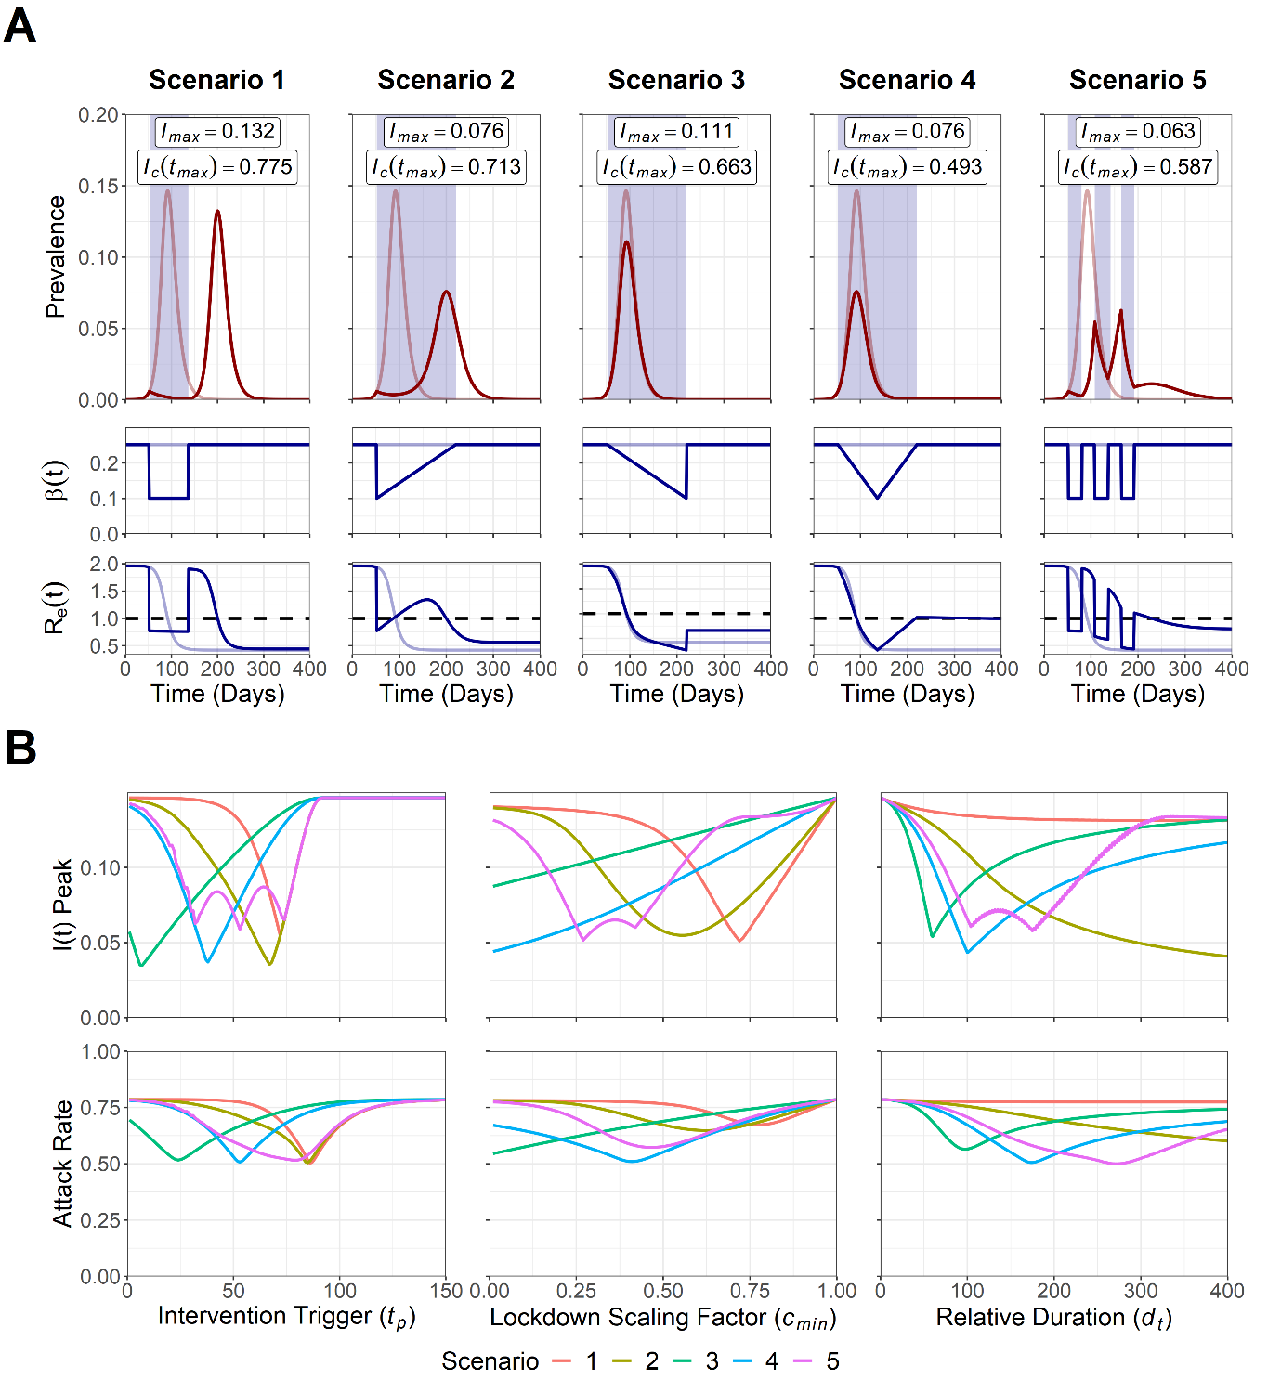

**Figure 1. A) Trajectory plots for the epidemic curve, *β(t)* reductions and *Re(t)* for the five intervention scenarios. B)** **Sensitivity analysis for intervention trigger point (*tp*), magnitude (*cmin*) and duration (*dt*) to minimise the peak prevalence, *Imax*, and attack rate, *Ic(tmax)*.** For A) pale red and blue lines depict unmitigated epidemic curve dynamics,blue shading indicates the intervention period and the dotted line depicts the *Re(t)* = 1 threshold for sustained epidemic growth. *Imax* and *Ic(tmax)* values are annotated for each scenario.Note that for B) the *dt* axis for scenario 1 was transformed into a relative axis to allow for comparison across scenarios, with the relative axis of 0 ≤ *dt* ≤ 400 being equal to an absolute *dt* range of 0 ≤ *dt* ≤ 200.

Sensitivity analyses were conducted to observe the sensitivity of the peak prevalence, *Imax*, and the attack rate, *Ic(tmax)*, to the intervention trigger point (*tp*), magnitude (*cmin*) and duration (*dt*) (Figure 1B). Optimal parameter values for all scenarios can be found summarised in the supplementary material (Table S3). A specific optimal trigger point was observed for all scenarios to minimise both *Imax* and *Ic(tmax)*, with these optimal values found within an early-intermediate trigger point parameter space (7 ≤ *tp* ≤ 74). While an optimum was identified for scenario 5 to minimise *Imax* (*tp* = 53), two other trigger points resulted in similar reductions to *Imax* (*tp* = 32/74). Scenarios 1, 3 and 4 were found to be highly sensitive to deviations from the optimal *tp* value, with steep increases in *Imax* and *Ic(tmax)* either side of the optimum. We note that if a suboptimal trigger point was chosen in scenario 2, it would be more beneficial to intervene earlier-than-optimal, with a gentler increase in *Imax* as *tp* is reduced from the optimal value, compared to later-than-optimal *tp* values.

Stronger interventions were more optimal to minimise *Imax* and *Ic(tmax)* for scenario 3 and 4 (*cmin* → 0). In contrast, intermediate strength interventions were found to be more optimal in scenario 1, 2 and 5 (*cmin* = 0.72/0.77, 0.56/0.62, 0.27/0.47) for *Imax*/*Ic(tmax)* respectively. We note that if suboptimal intervention magnitudes were chosen for scenario 1, 2 and 5, it was more beneficial to intervene too strongly than insufficiently. This was observed with decreases in *cmin* from the optimal value resulting in gentler increases in *Imax* and *Ic(tmax)* compared to greater-than-optimal *cmin* values.

Longer intervention durations were found to be optimal to reduce *Imax* and *Ic(tmax)* for scenario 2 (*dt* → 400). Interestingly, increasing the intervention duration was found to have minimal impact on either outcome measure in scenario 1, with the cessation of the intervention resulting in an identically sized epidemic peak regardless of the intervention duration. In contrast, intermediate length interventions were found to be optimal for scenario 3 and 4 (*dt* = 60/97, 100/174) for *Imax*/*Ic(tmax)* respectively, with scenario 5 displaying two relatively similar optimal points to minimise *Imax* (*dt* = 104/175). We note that if a suboptimal intervention duration was introduced for these scenarios, it was better to intervene for too long, with increases in *Imax* and *Ic(tmax)* being less severe in an intervention that was longer-than-optimal, compared to an intervention that was shorter-than-optimal.

To explore the interplay between multiple model parameters, a sensitivity analysis was next conducted to identify the optimal parameter space to minimise *Imax* and *Ic(tmax)* for a multi-dimensional parameter space: 1) Intervention trigger point (*tp*) and 2) Intervention duration (*dt*) (Figure 2). The optimal parameter space for all scenarios can be found summarised in the supplementary material (Table S3).

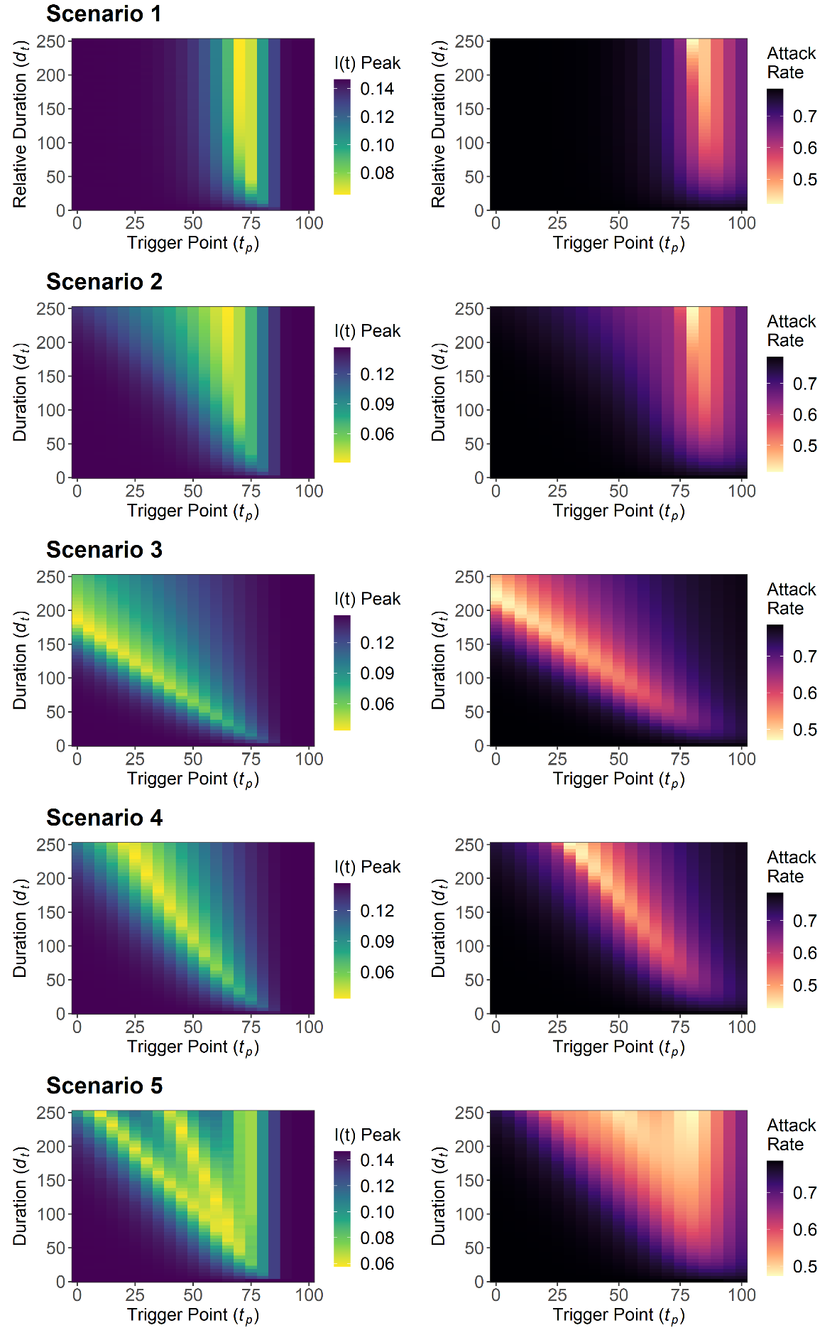

**Figure 2. Sensitivity analysis for the peak prevalence, *Imax*, and attack rate, *Ic(tmax)*, for intervention trigger point, *tp*, and duration, *dt*.** Note that the scenario 1 *dt* axis was transformed into a relative axis to allow for comparison across scenarios, with the relative axis of 0 ≤ *dt* ≤ 250 being equal to an absolute *dt* range of 0 ≤ *dt* ≤ 125.

A longer intervention duration (*dt* → 250) and intermediate trigger point (*tp* = 70/66 and *tp* = 80) was optimal for scenario 1 and 2 respectively to minimise *Imax* and *Ic(tmax)*. A contrasting pattern was observed in scenario 3 and 4, with shorter intervention durations found to maintain a near-optimal parameter space with a later intervention trigger. We note the existence of suboptimal trigger point “gaps” in scenario 5, with increases and decreases in *Imax* as the trigger point was varied. This resulted from the fixed periods between pulsed interventions, with these “gaps” increasing as the duration of the overall intervention increased. These “gaps” were found to be less pronounced for *Ic(tmax)* relative to *Imax*. Increasing the duration of the intervention had compensatory effects for scenario 2, 3, 4 and 5, with both *Imax* and *Ic(tmax)* becoming less sensitive to deviations from the optimal intervention trigger point as the duration of the intervention was increased. This suggests that increasing the duration of can make the intervention more robust to optimal trigger point implementation error.

The sensitivity analysis was repeated with *cmin* = 0.25/0.5/0.75 to assess the sensitivity of the *dt*/*tp* relationship to alterations to the magnitude of the intervention (Figure S3, S4). Low-intermediate *cmin* values of 0.25 (scenario 1, 2 and 3) and 0.5 (scenario 3 and 4) were found to be more optimal to minimise *Imax*, with the lowest explored value of *cmin* being optimal to minimise *Ic(tmax)* for all scenarios.

Two sequentially implemented interventions for each of the five scenarios was next modelled to explore the introduction of NPIs at a later date to tackle epidemic resurgence. Descriptive trajectory plots for each of the five multi-intervention scenarios can be found in the supplementary material (Figure S5). We note a higher value of *Imax* for scenarios 2 and 5 and the existence of an increased number of epidemic peaks for scenario 1 and 4 relative to the single-intervention scenarios. This can be attributable to the shorter intervention duration used for the multi-intervention scenarios.

A sensitivity analysis was conducted for the multi-intervention model to explore the optimal parameter space to minimise *Imax* and *Ic(tmax)* for two sets of parameters: 1) intervention 1 and 2 trigger point, *tp1* and *tp2,* and 2) intervention 1 and 2 magnitude, *cmin1* and *cmin2* (Figure 3). The optimal parameter space for all scenarios can be found summarised in the supplementary material (Table S3).

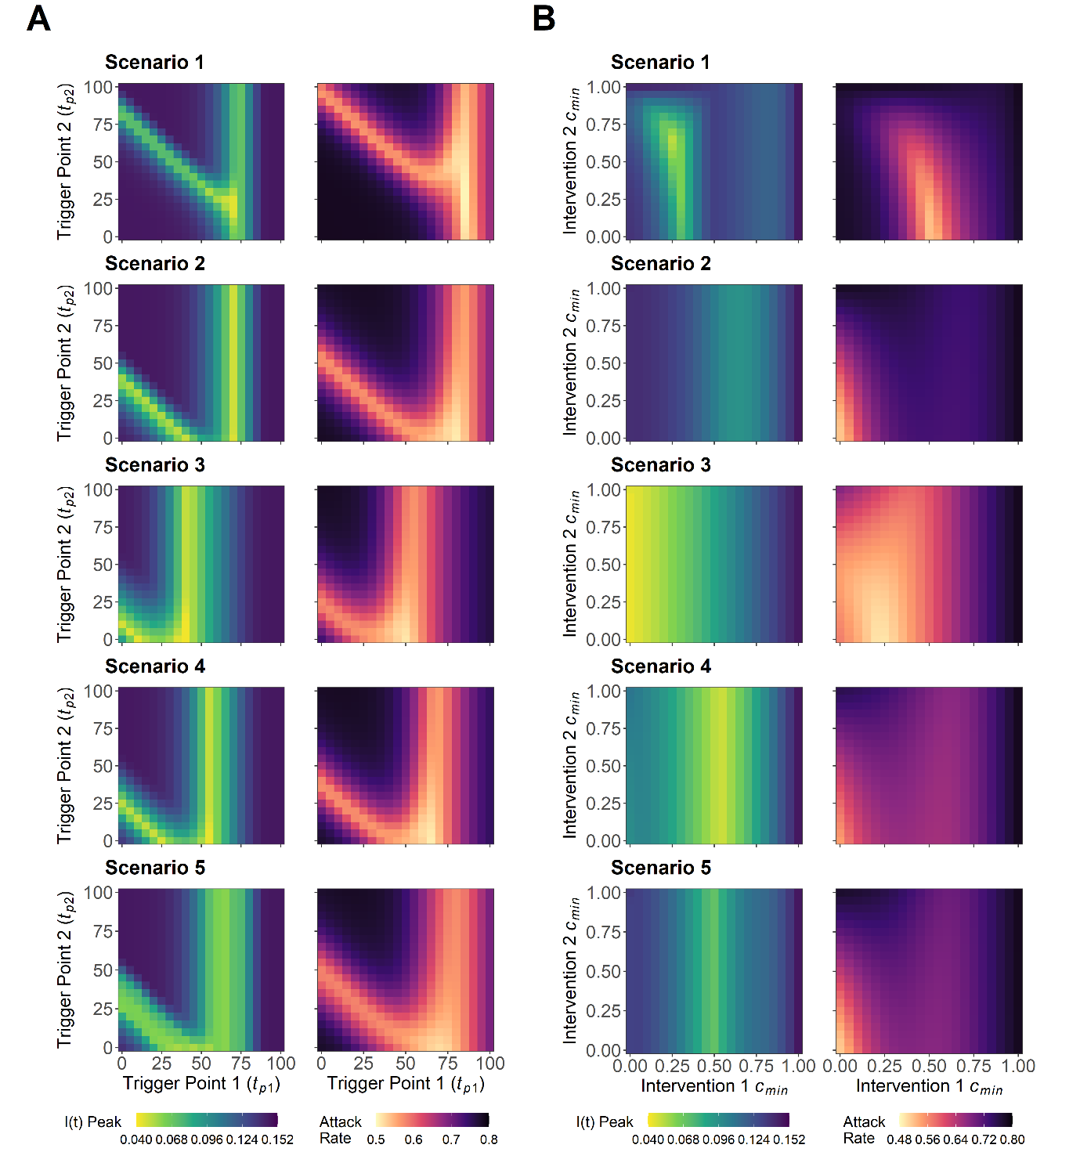

**Figure 3. A) Sensitivity analysis for the peak prevalence, *Imax*, and attack rate, *Ic*(*tmax*), for intervention 1 trigger point, *tp1*, and intervention 2 trigger point, *tp2*. B) Sensitivity analysis for the** **minimum value of scaling factor *c(t)* for intervention 1, *cmin1*, and intervention 2, *cmin2*.**

A large range of trigger points for intervention 2 (1 ≤ *tp2* ≤100) were found to result in near-optimal reductions to *Imax* and *Ic(tmax)*, on the condition that the optimal trigger point for intervention 1 was achieved (50 ≤ *tp1* ≤ 65) (Figure 3A). This was found to differ if a suboptimal earlier intervention 1 trigger point was chosen, with only a narrow selection of optimal intervention 2 trigger points able to compensate for a suboptimal *tp1* value. The choice of a later-than-optimal intervention 1 trigger was found to negate the ability for an intervention 2 trigger to prevent increases in *Imax* and *Ic(tmax)*, suggesting that it is better to introduce the initial intervention earlier, rather than later, if the optimal intervention 1 trigger point is unknown. Extending the duration of intervention 1 and 2 did little to alter the optimal trigger points for all scenarios (Figure S6-10).

A large range of intervention 2 magnitudes (0 ≤ *cmin2* ≤ 1) were found to provide near-optimal reductions to *Imax*, on the condition that the magnitude of intervention 1 was sufficiently optimised for scenario 2, 4 and 5 (Figure 3B). This suggests that for these scenarios, it is critical to focus on optimising the initial intervention to minimise *Imax*. A different optimal parameter space was identified to minimise *Ic(tmax)* for these three scenarios, with strong reductions to both intervention 1 and 2 being favoured (*cmin1*/*cmin2* → 0). Scenario 3 displayed subtly different dynamics, with intervention 1 ideally being as strong as possible to minimise *Imax* (*cmin1* → 0) and an intermediate magnitude to minimise *Ic(tmax)* (*cmin1* = 0.23). Scenario 1 was found to be optimal at an intermediate parameter space (*cmin1* = 0.26/0.62, *cmin2* = 0.52/0) for *Imax* and *Ic(tmax)* respectively. Increases in the duration of intervention 1 allowed for greater reductions to *Imax* and *Ic(tmax)* for a given *cmin1*/*cmin2* parameter space, relative to baseline parameters (Figure S11-15). The exception was scenario 3, with an increased intervention 1 duration also increasing the values of *Imax* and *Ic(tmax)* obtained over the explored *cmin1*/*cmin2* parameter space.

## **DISCUSSION**

This work builds on previous epidemiological modelling (9-15) to explore the optimal parameter space to minimise peak prevalence, *Imax*, and the attack rate, *Ic(tmax)*, across five different NPI scenarios. We identified an optimal parameter space for all considered intervention scenarios, with each scenario capable of minimizing both *Imax* and *Ic(tmax)* for a given set of optimal parameter values. However, we note that the exact value of the optimal parameter space is highly nuanced, and often highly sensitive to changes to the explored model parameters.

The optimal parameter space was found to be strongly influenced by the balance between the intervention peak timing and *cmin*. Matching the timing of an intervention to the epidemic peak has been explored previously (9, 10). However, we demonstrate that it is also necessary to match the timing of the epidemic peak with the greatest magnitude of the intervention (*cmin*/*cmin1*/*cmin2*) if reductions to *β(t)* vary. This can be intuitively observed by comparing scenario 2 (*cmin* at *tp*) and scenario 3 (*cmin* at *tp* + *dt*) (Figure 2), with scenario 2 being optimal at a later trigger point to coincide with the early *cmin* reduction and scenario 3 optimal with an earlier trigger to coincide with the later *cmin* reduction. We also note the existence of optimal intermediate *cmin* values facilitating the build-up of infection-induced, protective immunity during the intervention. This phenomenon is well reported in modelling literature, with time-limited interventions found to be optimal when *Re(t)* is maintained near the threshold for sustained transmission (*Re(t)* ≈ 1) (27).

However, attainment of these optima in practice is likely to be difficult (9). The ongoing COVID-19 outbreak has highlighted the limited capacity of policy-makers to effectively micromanage the course of an outbreak (31). Factors such as varying public compliance, imperfect disease surveillance, policy miscommunication, confounding parallel interventions and implementation lag between the introduced interventions and observable changes in disease prevalence, will contribute to large levels of intervention implementation error (8, 32, 33). If placed in the context of the narrow parameter optima observed throughout this study, these effects will likely have substantial epidemiological consequences.

An alternative approach could involve suboptimal interventions that are more robust to implementation error. Due to the relative insensitivity of these robust interventions to imperfect parameter choices, these suboptimal intervention strategies will likely excel in uncertain real-time outbreaks where the current epidemiological situation is often unknown. Parallels of these interventions can be observed in the ongoing COVID-19 outbreak, with recurring themes of “hit it hard and fast” providing simple, yet robust advice to policy makers (34, 35). We note that for a single time limited intervention, the most effective suboptimal strategy to minimise *Imax* and *Ic(tmax)* can be achieved by intervening stronger and for longer than what is considered optimal (Figures 1, 2). Similarly, for the multi-intervention scenario, an earlier and stronger intervention can provide robust reductions to *Imax* and *Ic(tmax)* under suboptimal circumstances (Figure 3). However, this only holds true in the context of the initial intervention, with this acting as a delaying action, allowing for successive interventions to compensate and further reduce *Imax* and *Ic(tmax)*. This highlights the additional role of suboptimal interventions to permit future decision making when the current epidemiological situation is uncertain. This strategy is corroborated in literature, with suggestions that policy makers could use an earlier intervention to delay the epidemic peak if the optimal intervention strategy is unknown, providing time for the build-up of healthcare capacity and the opportunity for later interventions to course-correct (9).

We note that population “lockdown” measures have been presented as an integral part of a package of measures, used to drive down the level of infection and “buy” time for the introduction of more sustainable measures, such as contact tracing or vaccination (36, 37). We note that in the context of delaying the epidemic peak, it is universally more optimal to introduce the initial “lockdown” measures earlier, more strongly and for as long as necessary, until more sustainable intervention measures can be introduced indefinitely (Figure S26). This corroborates the results obtained from the suboptimal analysis of the time-limited single/multi intervention scenario (Figure 2, 3), and provides support for the current rationale of “hard and fast” introduction of intervention measures. However, this also highlights the importance of prioritising the development of these sustainable measures, with the harsh consequences of severe, lengthy NPI measures making indefinite delaying actions expensive and ultimately unsustainable.

We note that an SEIR framework could be considered more accurate to describe the epidemiological characteristics of SARS-COV-2, resulting in a delay between the intervention and observed effects in *I(t)* (Figure S27). However, this was considered unnecessary, with the aim of this study to describe the existence and patterns of intervention optima, and not forecast or describe the exact timing of said optima. The socio-economic cost of each intervention was also not considered. Factors such as adherence have a large impact on intervention efficacy (25), and the inclusion of these factors in the model may potentially provide support for NPI strategies with dedicated ramping or pulsing periods, which aim to mitigate the socio-economic effects of strong NPIs.

An assumption of life-long immunity was also made following SARS-COV-2 infection. This choice was made due to the large amount of uncertainty regarding the immunological characteristics of the virus (38). Future research could include modelling impact of waning immunity or serological cross-reactivity and how this could impact the optimal and suboptimal parameter spaces highlighted in this study (39).A relatively simple disease metric was also used for this study, with an optimal intervention able to reduce maximum peak prevalence, *Imax*, and attack rate, *Ic(tmax)*. While outside of the scope of this study, the use of other epidemiologically relevant outcome measures such as occupied ICU capacity or deaths per 100,000 population may be of interest when investigating optimal COVID-19 interventions in a more policy-relevant context. This could also be complemented by an exploration into the impact of individual or population level variation of risk on intervention optimisation (40-42).

NPI optimisation has been highlighted in this study as a powerful tool to greatly mitigate the epidemiological impacts of a COVID-19 outbreak. This can be considered of significant relevance, with the recent reinstitution of NPIs and stricter measures being used to combat resurgent outbreaks. However, the results described in this study are highly nuanced, with narrow intervention optima and a number of other factors likely preventing the trajectory of an epidemic conforming uniformly to the dynamics observed in this study. We highlight suboptimal interventions as an alternative policy option, with these interventions being less prone to implementation error and more robust to epidemiological uncertainty. These interventions have the additional benefit of being a risk-averse approach, often favourable during the initial stages of the outbreak, where the impact of risky public health policy can lead to disastrous consequences.

Finally, we stress that it was not the intention of this study to propose any one strategy as a singular policy option for COVID-19 control. The evidence from this study should be taken into context with the work tirelessly undertaken by the wider epidemiological and modelling community. It is only through this collaboration and synthesis that effective and altruistic public health policy can be generated to combat the COVID-19 pandemic.

## **ACKNOWLEDGEMENTS AND FUNDING**

We thank Hannah Lepper for the useful comments during the drafting of this paper and the initial stages of model implementation. This study was supported by the Wellcome Trust PhD grant (215094/Z/18/Z).

## **REFERENCES**

1. Centers for Disease Control and Prevention. *Nonpharmaceutical Interventions (NPIs)*. [Internet]. United States: U.S. Department of Health & Human Services. 2020. [Updated 27/04/2020, cited 20/07/2020]. Available from: <https://www.cdc.gov/nonpharmaceutical-interventions/index.html>.

2. Cabinet Office. *Guidance: Staying at home and away from others (social distancing)*. [Press release]. United Kingdom: Cabinet Office. 2020. [Updated 01/05/2020, cited 04/08/2020]. Available from: <https://www.gov.uk/government/publications/full-guidance-on-staying-at-home-and-away-from-others/full-guidance-on-staying-at-home-and-away-from-others>.

3. Nicola M, Alsafi Z, Sohrabi C, Kerwan A, Al-Jabir A, Iosifidis C, et al. The socio-economic implications of the coronavirus pandemic (COVID-19): A review. *Int J Surg*. 2020. 78:185-93.

4. Pierce M, Hope H, Ford T, Hatch S, Hotopf M, John A, et al. Mental health before and during the COVID-19 pandemic: a longitudinal probability sample survey of the UK population. *Lancet Psychiatry*. [Internet]. 2020. S2215-0366(20)30308-4. Available from: https://doi.org/10.1016/S2215-0366(20)30308-4.

5. Pfefferbaum B, North CS. Mental Health and the Covid-19 Pandemic. *N Engl J Med*. 2020. 383(6):510-2.

6. Dickens BL, Koo JR, Lim JT, Park M, Quaye S, Sun H, et al. Modelling lockdown and exit strategies for COVID-19 in Singapore. *The Lancet Regional Health-Western Pacific*. [Internet]. 2020. e100004. Available from: https://doi.org/10.1016/j.lanwpc.2020.100004.

7. Daly M. *Coronavirus: Earlier Scottish lockdown 'could have prevented 2,000 deaths'*. BBC News. [News]. 2020. [Updated 14/06/2020, cited 10/08/2020]. Available from: <https://www.bbc.co.uk/news/uk-scotland-52617895>.

8. Islam N, Sharp SJ, Chowell G, Shabnam S, Kawachi I, Lacey B, et al. Physical distancing interventions and incidence of coronavirus disease 2019: natural experiment in 149 countries. *BMJ*. 2020. 370:m2743.

9. Morris DH, Rossine FW, Plotkin JB, Levin SA. Optimal, near-optimal, and robust epidemic control. *arXiv*. [Preprint]. 2020. Available from: arXiv:200402209.

10. Di Lauro F, Kiss IZ, Miller J. The timing of one-shot interventions for epidemic control. *medRxiv*. [Preprint]. 2020. Available from: https://doi.org/10.1101/2020.03.02.20030007.

11. Gevertz J, Greene J, Tapia CHS, Sontag ED. A novel COVID-19 epidemiological model with explicit susceptible and asymptomatic isolation compartments reveals unexpected consequences of timing social distancing. *medRxiv*. [Preprint]. 2020. Available from: https://doi.org/10.1101/2020.05.11.20098335.

12. Miclo L, Spiro D, Weibull J. Optimal epidemic suppression under an ICU constraint. *arXiv*. [Preprint]. 2020. Available from: arXiv:200501327.

13. Rawson T, Brewer T, Veltcheva D, Huntingford C, Bonsall MB. How and when to end the COVID-19 lockdown: an optimization approach. *Frontiers in Public Health*. 2020. 8:262.

14. Bin M, Cheung P, Crisostomi E, Ferraro P, Lhachemi H, Murray-Smith R, et al. On fast multi-shot covid-19 interventions for post lock-down mitigation. *arXiv*. [Preprint]. 2020. Available from: https://arxiv.org/abs/2003.09930v5.

15. Sadeghi M, Greene J, Sontag E. Universal features of epidemic models under social distancing guidelines. *bioRxiv*. [Preprint]. 2020. Available from: https://doi.org/10.1101/2020.06.21.163931.

16. Grasselli G, Pesenti A, Cecconi M. Critical Care Utilization for the COVID-19 Outbreak in Lombardy, Italy: Early Experience and Forecast During an Emergency Response. *JAMA*. 2020. 323(16):1545–1546.

17. Li R, Rivers C, Tan Q, Murray MB, Toner E, Lipsitch M. Estimated Demand for US Hospital Inpatient and Intensive Care Unit Beds for Patients With COVID-19 Based on Comparisons With Wuhan and Guangzhou, China. *JAMA Netw Open*. 2020. 3(5):e208297.

18. Kermack WO, McKendrick AG. A contribution to the mathematical theory of epidemics. *Proceedings of the royal society of london Series A, Containing papers of a mathematical and physical character*. 1927. 115(772):700-21.

19. Pan A, Liu L, Wang C, Guo H, Hao X, Wang Q, et al. Association of Public Health Interventions With the Epidemiology of the COVID-19 Outbreak in Wuhan, China. *JAMA*. 2020. 323(19):1915-1923.

20. Pellis L, Scarabel F, Stage HB, Overton CE, Chappell LH, Lythgoe KA, et al. Challenges in control of Covid-19: short doubling time and long delay to effect of interventions. *arXiv*. [Preprint]. 2020. Available from: https://doi.org/10.1101/2020.04.12.20059972.

21. Petersen E, Koopmans M, Go U, Hamer DH, Petrosillo N, Castelli F, et al. Comparing SARS-CoV-2 with SARS-CoV and influenza pandemics. *Lancet Infect Dis*. [Internet]. 2020. Available from: https://doi.org/10.1016/S1473-3099(20)30484-9.

22. Zhou L, Liu JM, Dong XP, McGoogan JM, Wu ZY. COVID-19 seeding time and doubling time model: an early epidemic risk assessment tool. *Infect Dis Poverty*. 2020. 9(1):76.

23. Flaxman S, Mishra S, Gandy A, Unwin HJT, Mellan TA, Coupland H, et al. Estimating the effects of non-pharmaceutical interventions on COVID-19 in Europe. *Nature*. 2020. 257–261

24. Anderson RM and May RM. *Infectious diseases of humans : dynamics and control*. New York: Oxford University Press. 1991.

25. Davies NG, Kucharski AJ, Eggo RM, Gimma A, Edmunds WJ, Centre for the Mathematical Modelling of Infectious Diseases C-wg. Effects of non-pharmaceutical interventions on COVID-19 cases, deaths, and demand for hospital services in the UK: a modelling study. *Lancet Public Health*. 2020. 5(7):e375-e85.

26. Flaxman S, Mishra S, Gandy A, Unwin H, Coupland H, Mellan T, et al. *Report 13: Estimating the number of infections and the impact of non-pharmaceutical interventions on COVID-19 in 11 European countries*. [Report]. Imperial College London. 2020. Available from: https://doi.org/10.25561/77731.

27. Anderson RM, Heesterbeek H, Klinkenberg D, Hollingsworth TD. How will country-based mitigation measures influence the course of the COVID-19 epidemic?. *Lancet*. 2020. 395(10228):931-4.

28. R Development Core Team. *R: A language and environment for statistical computing*. (v3.6.2). Vienna: R: Foundation for Statistical Computing. 2020. Available from: <https://www.r-project.org/>.

29. RStudio Team. *RStudio: Integrated Development for R*. (v1.3.959). Boston: RStudio, PBC. 2020. Available from: <https://rstudio.com/>.

30. Soetaert KE, Petzoldt T, Setzer RW. Solving differential equations in R: package deSolve. Journal of statistical software. 2010. 33(9).

31. Hunter DJ. Covid-19 and the Stiff Upper Lip - The Pandemic Response in the United Kingdom. *N Engl J Med*. 2020. 382(16):e31.

32. Media P. Fewer young adults sticking to lockdown rules, UK study shows. *The Guardian*. [News]. 2020. [Updated 01/08/2020, cited 04/08/2020]. Available from: <https://www.theguardian.com/world/2020/may/21/fewer-young-adults-sticking-uk-lockdown-rules-study-coronavirus>.

33. Elliot AJ, Harcourt SE, Hughes HE, Loveridge P, Morbey RA, Smith S, et al. The COVID-19 pandemic: a new challenge for syndromic surveillance. *Epidemiol Infect*. 2020. 148:e122.

34. Lagan B. ‘Hard and fast’ plan takes New Zealand through coronavirus crisis. *The Times*. [News]. 2020. [Updated 20/07/2020, cited 10/08/2020]. Available from: <https://www.thetimes.co.uk/article/hard-and-fast-plan-takes-kiwis-through-coronavirus-crisis-lnrxvtmxj>.

35. Baker MG, Wilson N, Anglemyer A. Successful Elimination of Covid-19 Transmission in New Zealand. *N Engl J Med*. 2020. 383:e56.

36. Ferretti L, Wymant C, Kendall M, Zhao L, Nurtay A, Abeler-Dorner L, et al. Quantifying SARS-CoV-2 transmission suggests epidemic control with digital contact tracing. *Science*. 2020. 368(6491).

37. Lurie N, Saville M, Hatchett R, Halton J. Developing Covid-19 vaccines at pandemic speed. *N Engl J Med*. 2020. 382(21):1969-73.

38. Mahase E. Covid-19: Where are we on immunity and vaccines?. BMJ. [Internet]. 2020. 370:m3096. Available from: https://doi.org/10.1136/bmj.m3096.

39. Kissler SM, Tedijanto C, Goldstein E, Grad YH, Lipsitch M. Projecting the transmission dynamics of SARS-CoV-2 through the postpandemic period. *Science*. 2020. 368(6493):860-8.

40. Gomes MGM, Aguas R, Corder RM, King JG, Langwig KE, Souto-Maior C, et al. Individual variation in susceptibility or exposure to SARS-CoV-2 lowers the herd immunity threshold. *medRxiv*. [Preprint]. 2020. Available from: https://doi.org/10.1101/2020.04.27.20081893.

41. Britton T, Ball F, Trapman P. A mathematical model reveals the influence of population heterogeneity on herd immunity to SARS-CoV-2. *Science*. 2020. 369(6505): 846-849

42. Davies NG, Klepac P, Liu Y, Prem K, Jit M, group CC-w, et al. Age-dependent effects in the transmission and control of COVID-19 epidemics. *Nat Med*. 2020. 26(8):1205-11.